Anonymous Survey Results Using Qualtrics Panels
Institutional Research, Effectiveness, and Planning

Purpose
If you request a panel from the Survey Panel Group at the University of Mississippi to survey students, faculty, staff and alumni, you will need to make the results anonymous. This option is generally required when you have IRB approval.

General Information:
You can only perform these steps once you have finished writing and editing your Qualtrics survey. You will need (1) a written/created Qualtrics survey and (2) a panel of potential respondents to complete these steps. If you have requested a panel from IREP/SPG, you will receive instructions to download the panel file.

Step 1: Log in
Open Qualtrics and log into your University of Mississippi account.

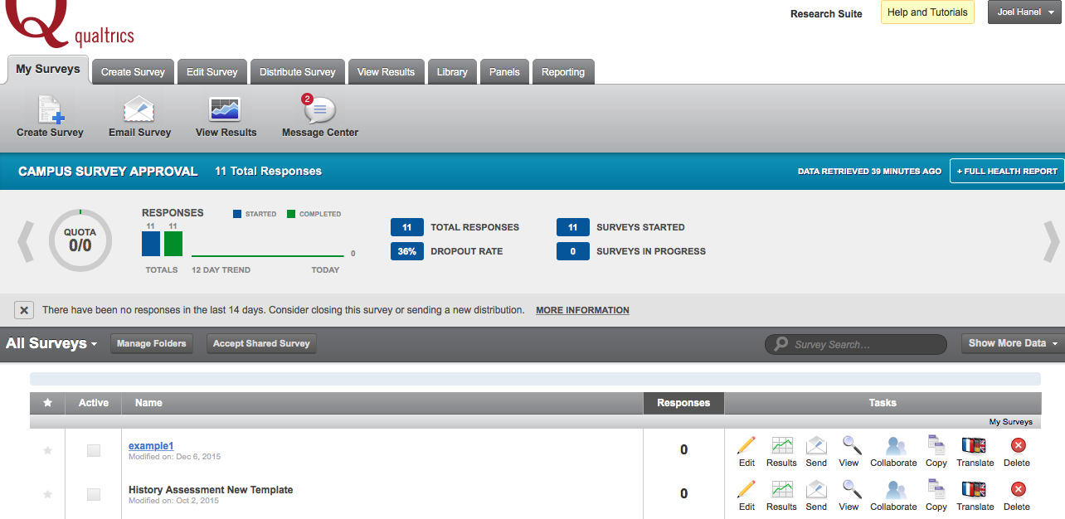

Step 2: Creating your panel
After creating your survey, proceed to the Panels tab at the top of the page.

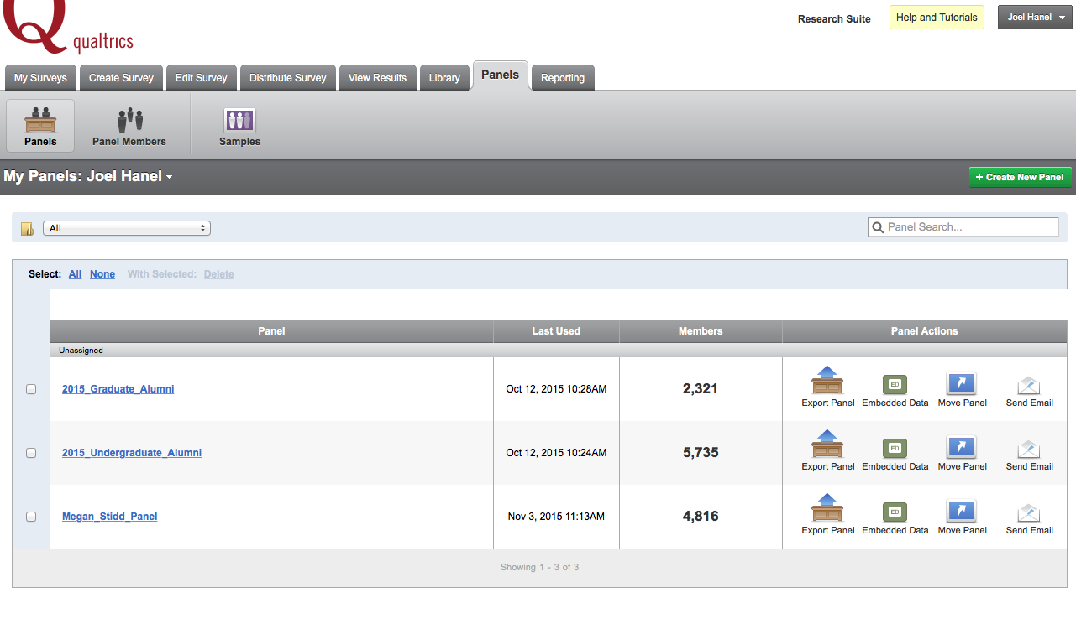

Step 3: Create a new panel spreadsheet
Once you have downloaded your panel from IREP on my.olemiss, open the file in Excel.
Make sure the file is a .csv, and includes the columns FirstName, LastName and Email. You may have to change the names of these columns in order to import the file in Qualtrics. (Note that you do not need FirstName and LastName to send a survey, unless you wish to address each respondent in the recruitment email).

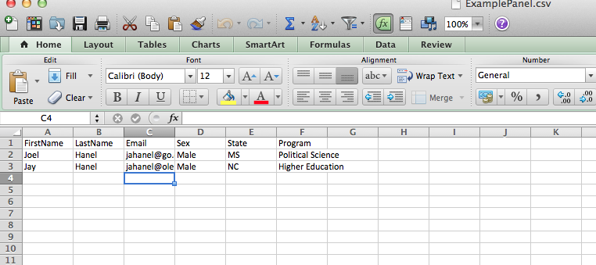

Step 4a: Upload the new panel to Qualtrics

Back in Qualtrics select the Create New Panel Button in green.

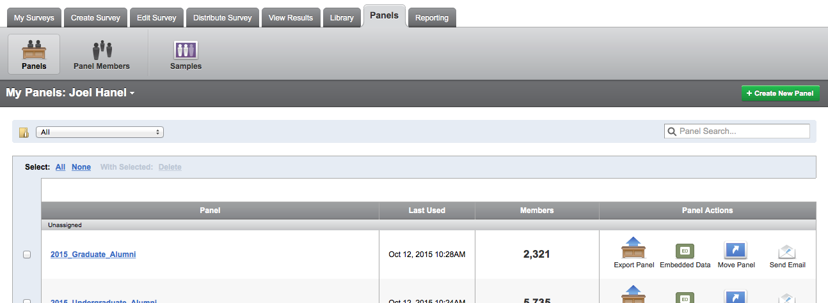

Step 4b: Upload the new panel to Qualtrics
Name your panel and select Create.

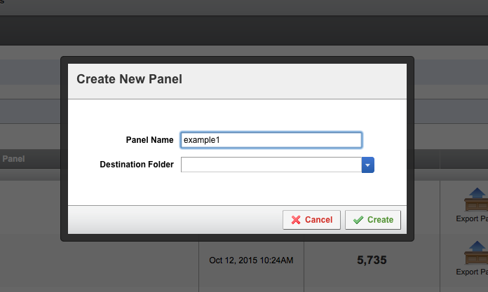

Step 4c: Upload the new panel to Qualtrics
Select Import from File

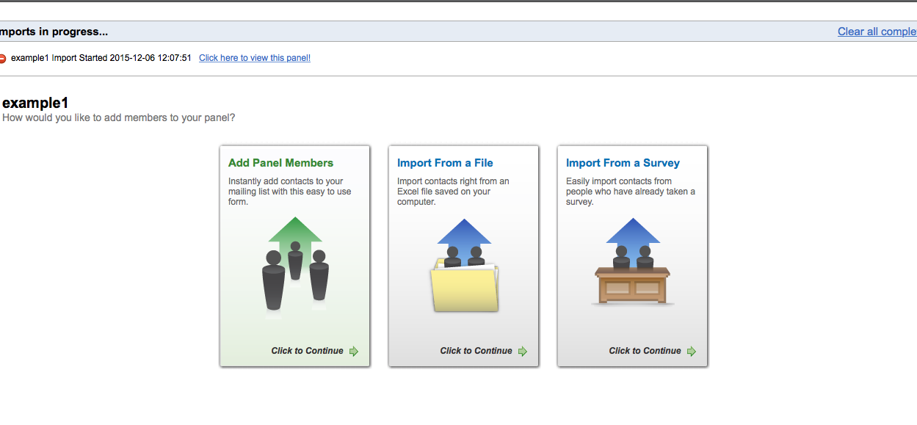

Step 4d: Upload the new panel to Qualtrics
Select Browse and find your panel saved in a .csv format.

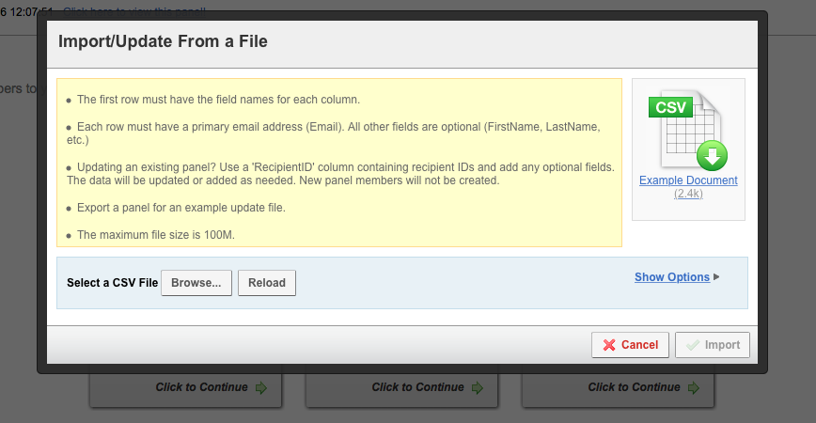

Step 4e: Upload the new panel to Qualtrics
If your file is correct, you should see the following screen. At the minimum, you should have an Email, column. Note that the file example has a sex, state and program column. These will be added to your survey results as Embedded Data. Select Import.

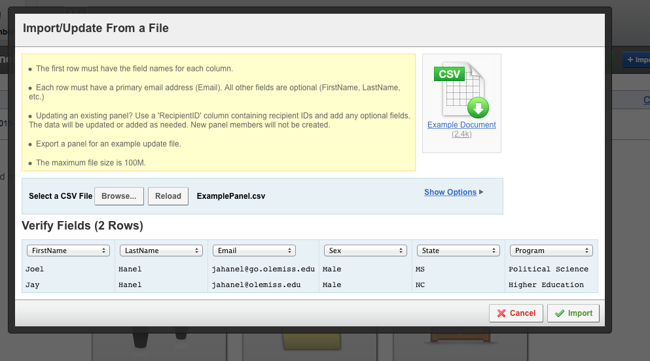

Step 5: Return to your survey, and select Survey Flow
Return to your survey and select the Survey Flow Tab

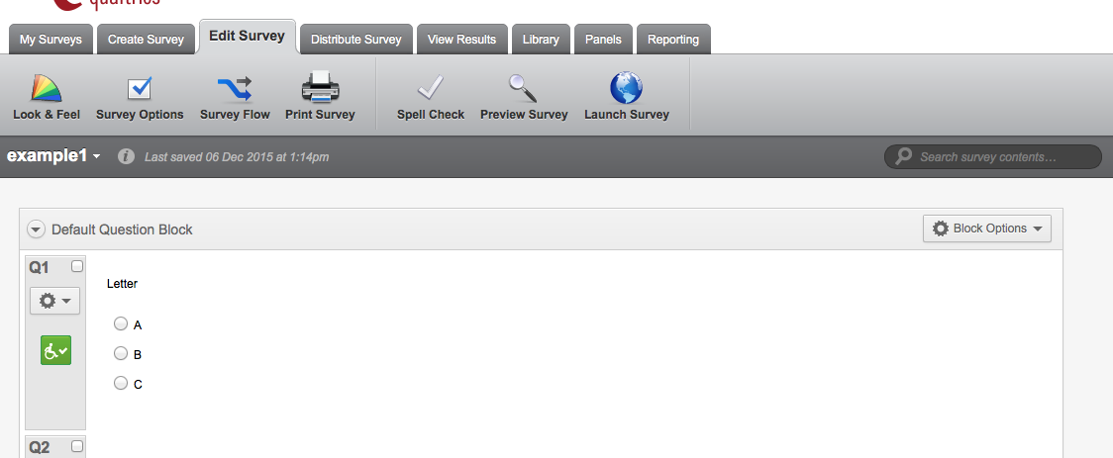

Step 6a: Add Embedded Data
In the survey flow, select Add New Element Here

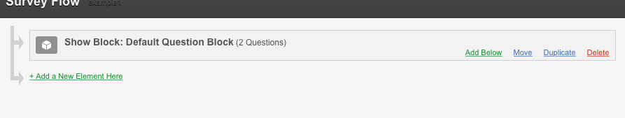

Step 6b: Add Embedded Data
Select Embedded Data.

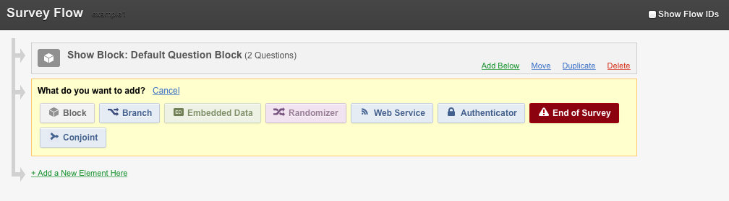

Step 6c: Add Embedded Data
Select Add From Panel
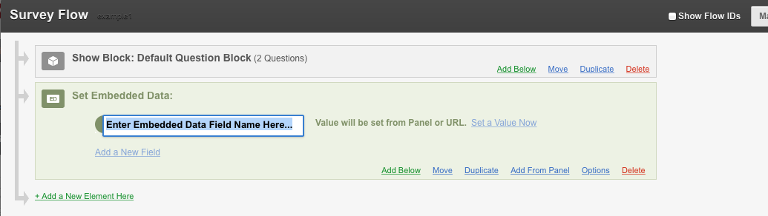

Step 6d: Add Embedded Data
Select your panel from the drop-down menu and click OK.

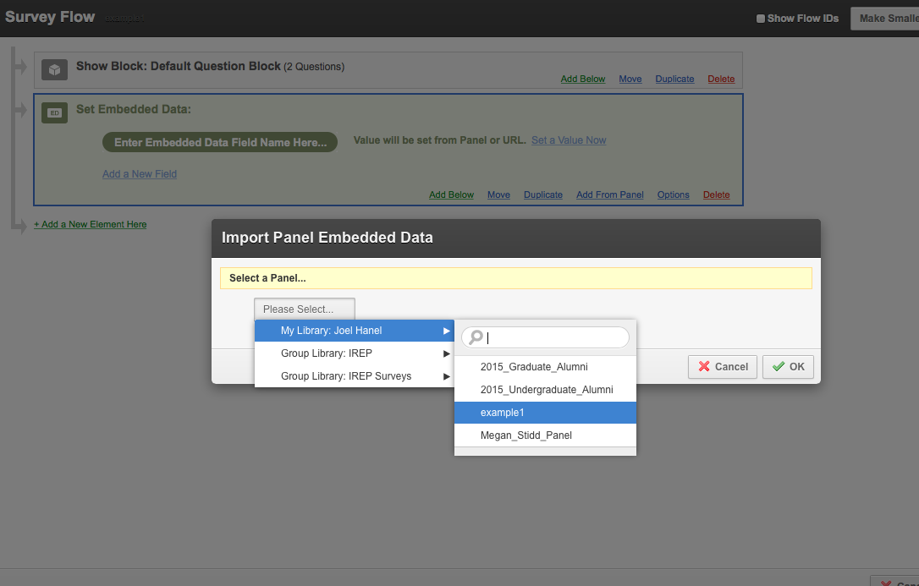

Step 6d: Add Embedded Data
Now your data is embedded into the survey. Once an respondents starts a survey, the embedded data will be added to the results.

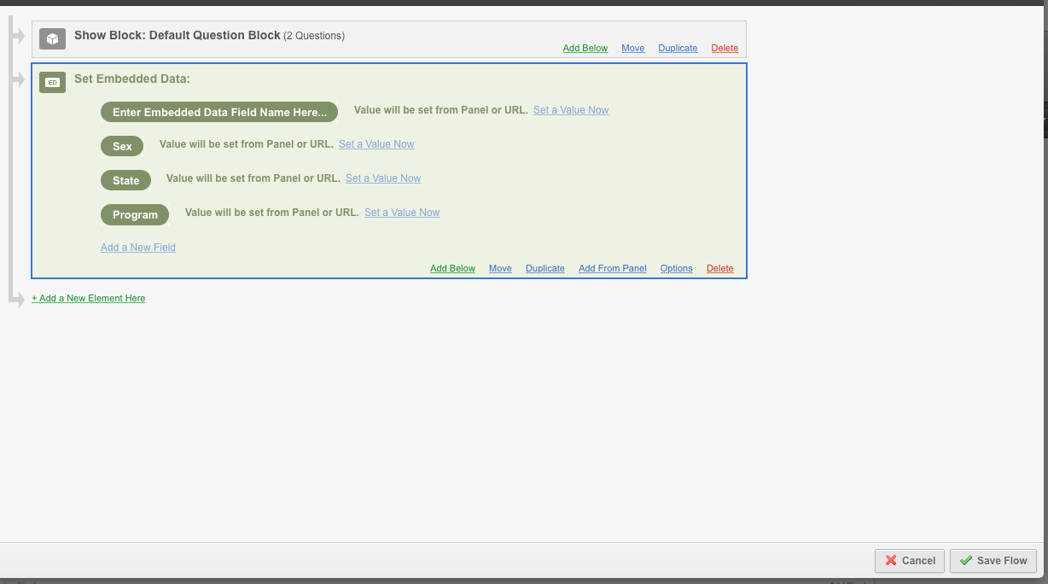

Step 7a: Making the results anonymous.
In the same Survey Flow menu select Add a New Element Here

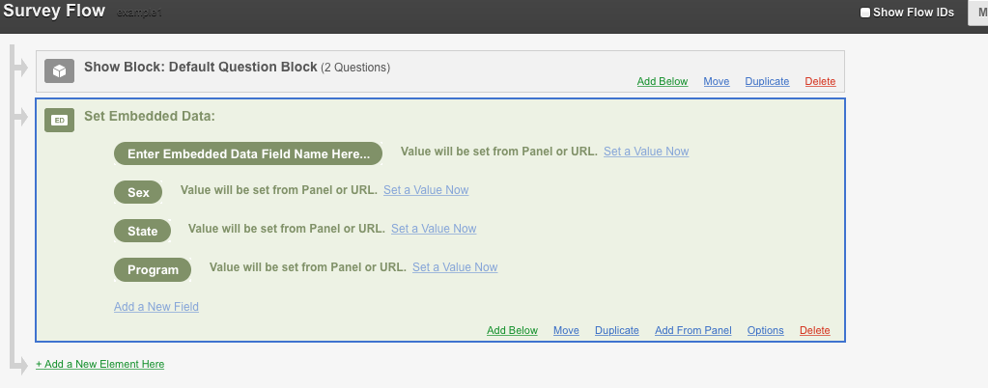

Step 7b: Making the results anonymous.
Select End of Survey and select Customize under the End of Survey Banner.

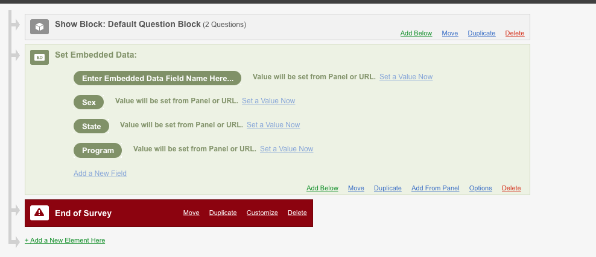

Step 7c: Making the results anonymous.
Select Override Survey Options and then Do NOT Record any personal information… and select OK.

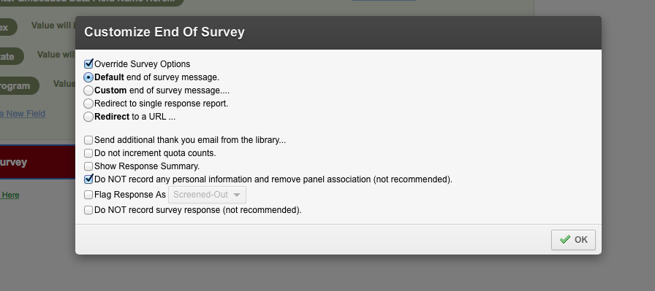

Step 8: Using the Panel Feature to Send out Surveys.
Under the Distribute Survey Tab select Email Survey. Under the To: dropdown, select your panel.
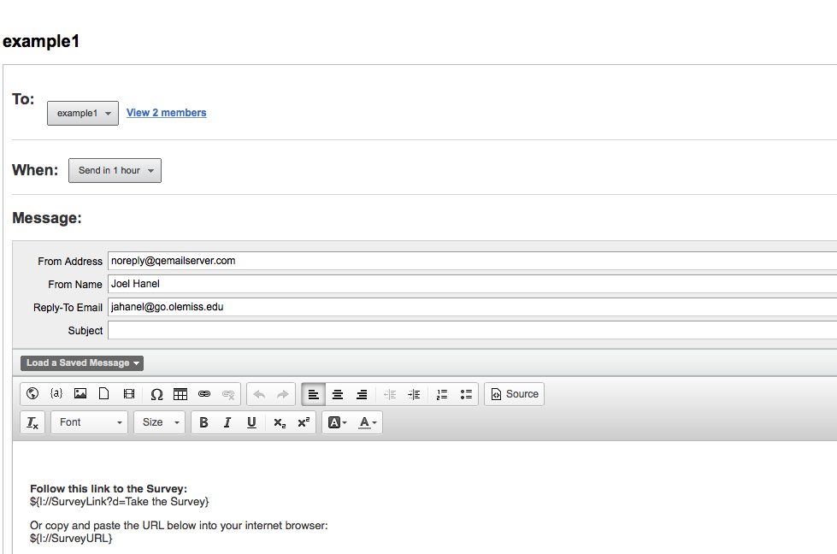

Step 9: Send Survey.
After saving your message to your panel (You will want to add your IRB approved recruitment message), hit schedule mailing.

